**Universidad Americana**



***Algoritmos y estructuras de datos***

**Integrante:**

* **Gabriel Antonio Rojas Uriarte**

**Marzo de 2025**

Ejercicio 1(Funciones)

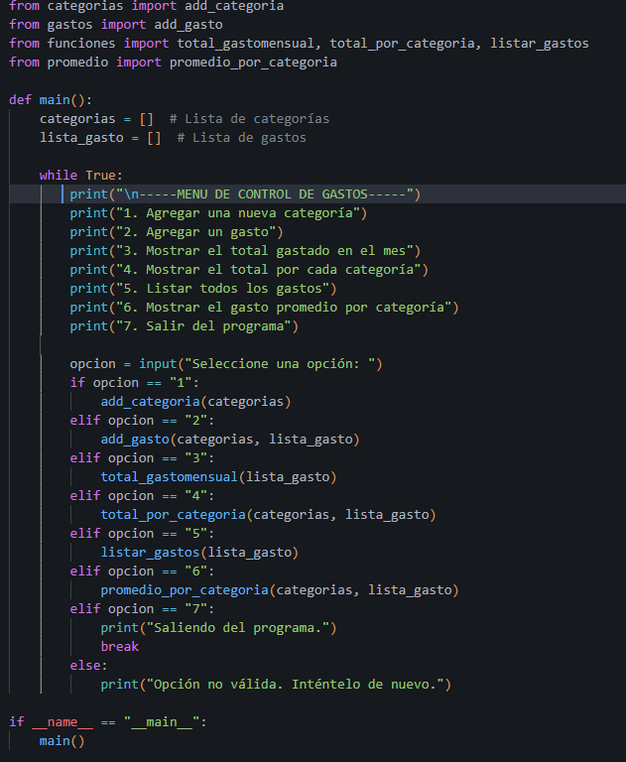

Terminal:

